EVALUTION TECHNIQUES & RESULTS
6.1 EVALUATION TECHNIQUES
This section presents the evaluation methods and results used for assessing the performance, accessibility, and best practices of the Semsary web platform. The objective is to ensure the platform maintains high standards of speed, user experience, scalability, and reliability.
- Front-End Evaluation:
We used Google Lighthouse, a powerful automated tool provided by Google to audit the quality of web pages. Lighthouse evaluates key performance indicators such as load speed, accessibility, SEO, and adherence to best practices. It generates detailed reports that guide improvements in front-end code and user experience.
- Back-End Evaluation:
For server-side evaluation, we utilized tools such as Apache JMeter to assess performance under load, OWASP for security vulnerability scanning, and Firebase Monitoring for real-time performance insights. Additionally, SQL Server Profiler was used to monitor database interactions and ensure optimal query execution.
6.2 FRONT-END RESULTS
Below are the front-end evaluation results of the Semsary platform using Google Lighthouse. The platform scored highly across all core categories, reflecting its responsiveness, accessibility, and user-centric design.
Metric | Score
Performance | 96
Progressive Web App | 100
Accessibility | 91
Best Practices | 94
SEO | 100
Metric | Value
First Contentful Paint | 1.650 ms
First Meaningful Paint | 1.650 ms
Speed Index | 1.720 ms
First CPU Idle | 3.200 ms
Time to Interactive | 3.250 ms
Estimated Input Latency | 12 ms

6.2.1 PERFORMANCE
The Performance score is a critical indicator that measures how quickly and efficiently the Semsary platform loads and becomes usable for users. Evaluated using Google Lighthouse, the performance score aggregates several key web vitals that directly impact user experience and satisfaction.
The Semsary platform achieved an impressive performance score of 96, indicating excellent front-end responsiveness and speed. Below are the primary metrics considered in this evaluation:
- First Contentful Paint (FCP):
Measured at 1,650 ms
This metric indicates the time at which the browser first renders any visible content. A fast FCP reassures users that the page is loading correctly.
- Time to Interactive (TTI):
Measured at 3,250 ms
TTI measures how long it takes for the page to become fully interactive. A lower TTI ensures users can interact with the page quickly without lag.
- Speed Index:
Measured at 1,720 ms
This metric reflects how quickly the page’s content is visually displayed. A lower value results in a faster perceived load time.
- First CPU Idle:
Measured at 3,200 ms
Indicates the first point when the page's main thread is sufficiently idle to handle input. It ensures responsiveness during initial interaction.
- Estimated Input Latency:
Measured at 12 ms
A measure of how quickly the site responds to user input. Lower latency results in a smoother and more responsive interface.
Although Total Blocking Time (TBT) and Largest Contentful Paint (LCP) were not explicitly reported in this test, they are inherently considered in the overall score, and their influence is reflected in the high performance achieved.
These results confirm that the Semsary platform delivers an optimized and fast-loading experience, which is essential for maintaining user engagement and satisfaction, particularly in a real estate platform where users frequently navigate between listings.
6.2.2 PROGRESSIVE WEB APP (PWA)
The PWA (Progressive Web App) score in Google Lighthouse is a metric that measures how well a website meets the criteria of being a progressive web app.
A progressive web app should feel and behave like a native mobile app, providing features such as push notifications, home screen installation, and full-screen mode.
The PWA score is based on several factors:
- If the site is Fast and reliable
- If the site is installable
- If the site is PWA Optimized.
6.2.3 ACCESSIBILITY
The accessibility audits cover a range of areas, such as proper use of headings, alternative text for images, keyboard navigation, color contrast, and more. This can help you identify and address accessibility issues to ensure your website is accessible to all users.
6.2.4 BEST PRACTICES
The Best Practices score checks the quality of the platform code, and whether it meets industry standards. This involves ensuring the page is fast, and secure and creates a good user experience. This score also takes into account any deprecated technologies (such as APIs).
6.3 BACK-END RESULTS
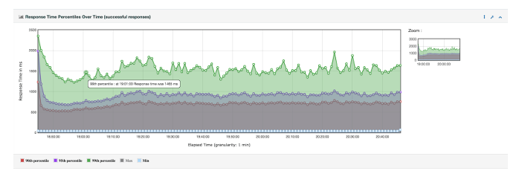
6.3.1 PERFORMANCE MONITORING
(Apache JMeter Report)
Description: Evaluates the responsiveness and stability of the platform under various loads. This includes load testing to simulate high traffic and response time measurements to assess how quickly the backend handles requests.
6.3.2 SECURITY TESTING

1. A01:2021 – Broken Access Control

Issue in Semsary: Unauthorized access to admin or landlord functions (e.g., publishing houses, managing complaints) if role-based authorization is not strictly enforced.
Impact: Attackers could perform admin-level operations such as deleting listings, changing prices, or viewing private data.
Mitigation: Implement strict role-based access control (RBAC) and verify permissions server-side for every sensitive action.

2. A02:2021 – Cryptographic Failures
Issue in Semsary: Insufficient encryption for sensitive data such as passwords, user identity documents, or payment data. Lack of HTTPS or TLS enforcement across all endpoints.
Impact: User data could be intercepted or tampered with during transmission. Could lead to identity theft, fraud, and platform distrust.
Mitigation: Enforce HTTPS/TLS site-wide. Store passwords using secure hashing algorithms (bcrypt). Encrypt sensitive data at rest and in transit.

3. A03:2021 – Security Misconfiguration
Issue in Semsary: Using default .NET or SQL Server configurations, or not restricting access to Firebase storage URLs.
Impact: Attackers could access internal API documentation, exposed endpoints, or stored apartment images/documents directly.
Mitigation: Lock down storage buckets with IAM policies. Disable unnecessary services and debug/error messages in production. Use security headers like CSP, X-Frame-Options.

4. A04:2021 – Identification and Authentication Failures
Issue in Semsary: Weak login system without rate-limiting, OTP validation bypass, or insecure JWT implementation.
Impact: Account takeover through brute-force or replay attacks. Impersonation of landlords or tenants.
Mitigation: Implement multi-factor authentication (MFA). Use secure, short-lived JWTs with strong signing algorithms. Rate-limit login and registration attempts.

5. A05:2021 – Software and Data Integrity Failures
Issue in Semsary: Use of invalidated or outdated open-source libraries (e.g., React, Tailwind, Firebase SDKs) or third-party APIs (like PayMob, Twilio).
Impact: May introduce known vulnerabilities, leading to arbitrary code execution or data leakage.
Mitigation: Use dependency scanning tools (e.g., Dependabot). Validate third-party APIs and restrict their scope with API keys and rate limits.

6. A06:2021 – Server-Side Request Forgery (SSRF)
Issue in Semsary: If image upload, feedback, or verification systems fetch remote URLs (e.g., for image validation or data parsing), SSRF may be possible.
Impact: Could allow attackers to make internal server requests and access protected resources.
Mitigation: Block internal IP ranges in requests. Validate and sanitize all URLs before requesting them server-side.

7. A07:2021 – Remote Code Execution (RCE)

Issue in Semsary: In Semsary, users (landlords or tenants) can upload images of rental houses. However, if the platform does not strictly validate the file type, MIME type, and size of uploaded content, an attacker can upload a malicious file disguised as an image.

Impact:
- Remote Code Execution (RCE):
If the server stores and serves the uploaded files without isolating them (e.g., on Firebase or CDN), and then executes them in a vulnerable environment (e.g., shared hosting or misconfigured CDN), the attacker can execute arbitrary commands.
- Defacement or Takeover:
Attackers may upload files that contain malicious scripts to be executed in the browser (XSS), or even backdoors on misconfigured servers.
- Denial of Service (DoS):
Uploading extremely large files can exhaust disk space or crash the image handling service.
- Bypass Business Logic:
Uploading non-image content may interfere with image previews or processing logic, leading to app crashes or unpredictable behavior.

Mitigation Recommendations:

Server-side validation:
- Check MIME type and extension (only allow image.png, image.jpeg, image.webp).
- Reject or sanitize files with dual extensions (file.php.jpg, file.exe.png).
- Reject files larger than a reasonable size (2 MB).
- Strip EXIF data from images before saving.

Isolation and sandboxing:
- Store files in object storage (Firebase Storage or S3), not on the server file system.
- Use Content-Disposition: attachment when serving uploads to prevent browser execution.

Scanning:
- Use libraries like Image Sharp (.NET) or Pillow (Python) to verify image integrity and sanitize them.
- Run uploaded files through a virus scanner (ClamAV).

Logging & Alerting:
- Log file upload activities, including type, size, and user ID.
- Alert on suspicious uploads or repeated failures.

8. A08:2021 – Rate Limit

Issue: Semsary lacks rate limiting on the comment/review system, allowing users to post unlimited comments in a short time without restrictions on frequency or volume.

Impact:
- Spam & Review Manipulation: Attackers can flood listings with fake positive or negative reviews.
- System Resource Abuse: Excessive comment submissions can increase server load and database bloat.
- Reputation Damage: Malicious users can unfairly degrade landlords’ credibility or inflate ratings.
- Reduced Platform Trust: Tenants may distrust reviews due to spam or manipulation.

Mitigation:
- Implement backend rate limits (1 comment per listing per 10 minutes).
- Enforce user-level and IP-based thresholds (10 comments/hour).
- Add frontend cool-downs and disable comment buttons after submission.
- Use logging and alerting to detect abuse patterns or bots.
- Optionally, add CAPTCHA for suspicious behavior.
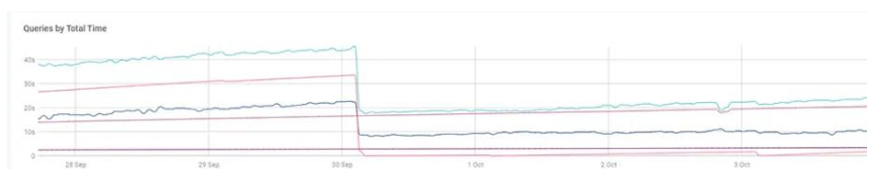
6.3.3 DATABASE PERFORMANCE
(SolarWinds Report)
Description: Evaluates the responsiveness and stability of the database under various loads. This includes load testing to simulate high traffic and response time measurements to assess how quickly the backend handles requests.

